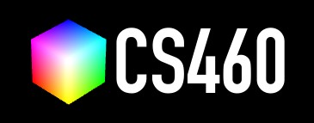

**University of Massachusetts Boston**

**CS460 Fall 2022 Name:** YOURNAME

**Due Date:** 09/12/2022

Assignment 1: Intro

**Part 1 (100 points):** Describe your favorite WebGL demo.

My favorite demo is ( <https://gaweph.github.io/TimeGame-WebGL-Demo/latest/> ) The authors created a game by integrating UNITY to WebGL. I was amazed how WebGL could be used for games at this level. The game was basic, based on colors one has to cross the bridge. There were only two levels enough to display the motive of the game. The best part is one can replay the level you have played the last time and last shows the time interval of your last played game. It is a perfect example for a beginner to understand and invent games of your own thinking! Though it is a small implementation of unity and WEBGL, I see a lot of potential in a beginner. Hence it is my favorite Demo.

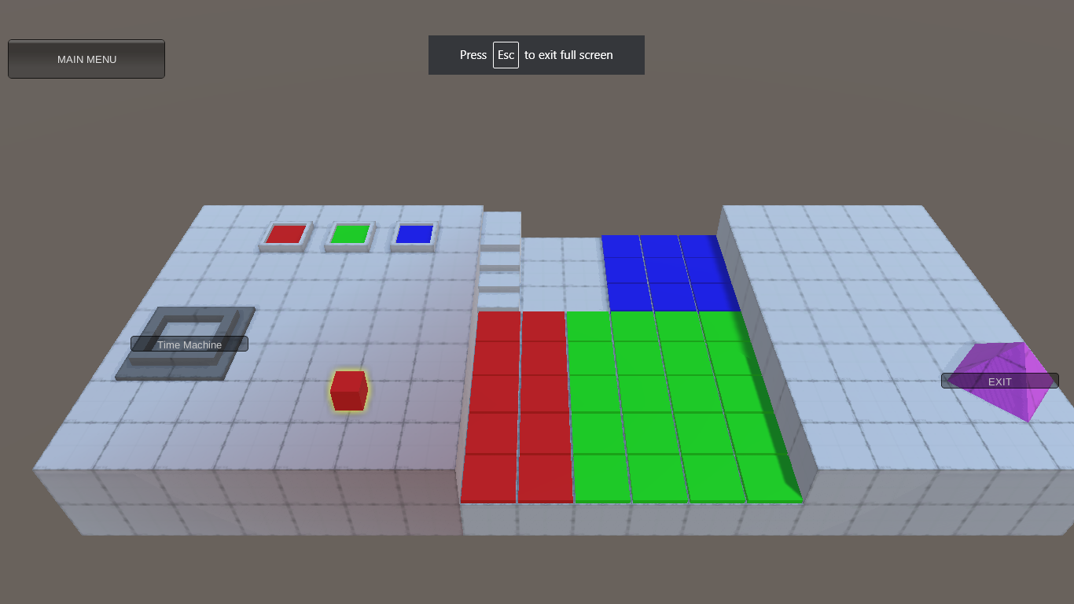

**Technologies used:**

* HTML/CSS/JavaScript
* Unity3d
* Chrome browser.

**Bonus (33 points):** If possible, try to host the project as your own Github repository and make it accessible via Github pages. Please make sure to credit the original authors. Then, link the repository here: https://github.com/Gaweph/TimeGame-WebGL-Demo

1